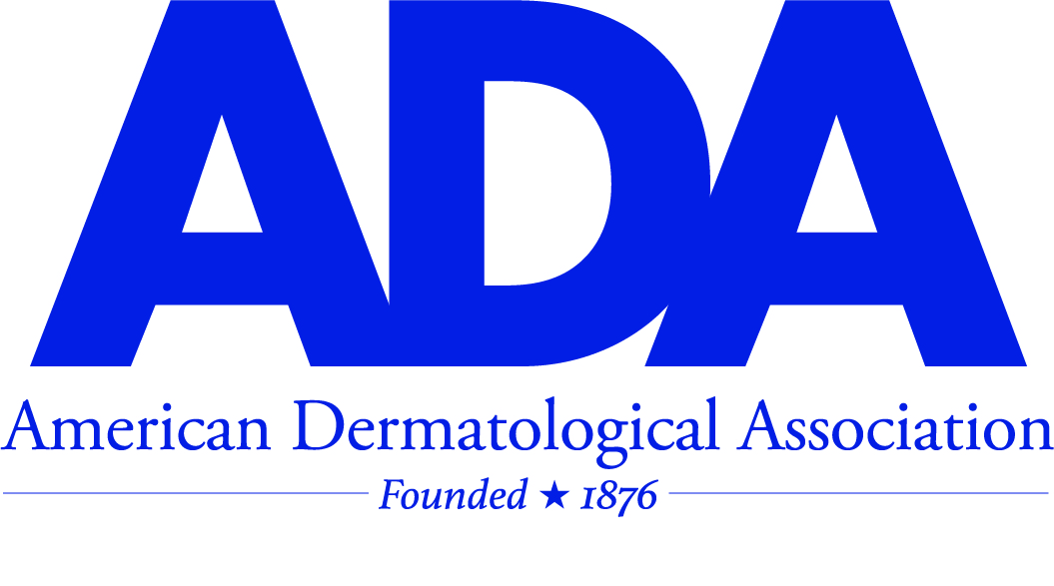

**Call for Applications: 2025 Early Career Research Award**

Are you ready to showcase your groundbreaking dermatology research on a national stage? The American Dermatological Association (ADA) is thrilled to announce the 2025 **Early Career Research Award**, a prestigious opportunity to highlight your innovative work to the leaders in dermatology.

This award celebrates exceptional research by rising stars in the field of dermatology and offers a platform to share findings and network with dermatology leaders at the **ADA Annual Meeting**. The awardee(s) will present their research during the meeting. This year, the meeting will be held at the stunning **Ritz Carlton Laguna Niguel in Dana Point, California**, from **October 29 – November 2, 2025**.

**Who Can Apply:**

* **Residents or fellows** in an ACGME-accredited dermatology training program. Resident or fellow applicants must have the approval and attestation of their chairperson or chief and research mentor for submission and meeting attendance.
* **Board-certified dermatologists** within the first 5 years of completing their training.

**What’s in it for You?**

* Present your completed or nearly completed research to the renowned ADA membership.
* Complimentary attendance, including air and ground travel, room, and board.
* A **$500 monetary stipend** to support your continued research journey.

Any research topic in dermatology is eligible, so whether your work delves into clinical breakthroughs, basic science, or public health, we want to see it!

Don’t miss this chance to advance your career, network with esteemed colleagues, and enjoy the recognition you deserve in a breathtaking location.

**The Deadline** is **June 1, 2025.**

<http://www.ada1.org/awards-grants/cfp>

Email: ameriderm1930@gmail.com

Phone: 305-804-1150