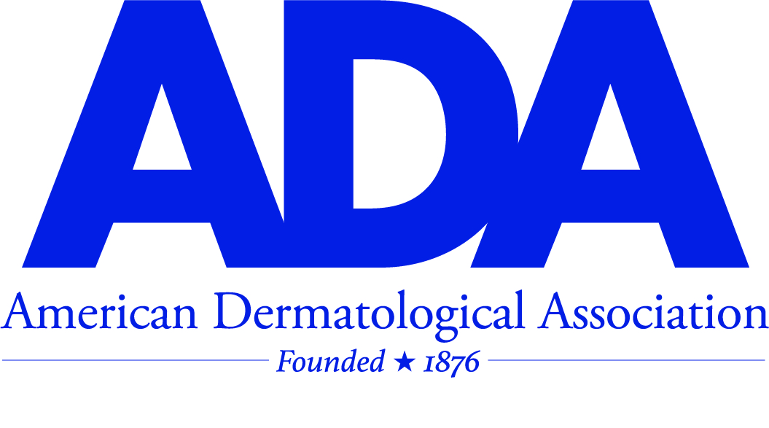

**2025 RESIDENT/FELLOW RESEARCH AWARD**

**CALL FOR PROPOSALS - GENERAL INFORMATION AND REQUIREMENTS**

The American Dermatologic Association is now accepting applicants for the 2025 ADA Dermatology Resident/Fellow research award. Individuals whose research is specifically related to the following subjects will be chosen:

Research should address one of the following subjects and must be completed at the time the application is submitted. To be considered for this award, the topic of your project should be related to novel studies involving:

**1) The integral nature of dermatology to the House of Medicine.**

**OR**

**2) Issues and matters that could lead to the marginalization of dermatology.**

1. Awardee(s) are required to present their research findings to the general membership of the American Dermatological Association (ADA) at the Annual meeting taking place from October 29, 2025 – November 2, 2025 at the Ritz Carlton Laguna Niguel in Dana Point, California. Awardees are expected to attend the entire meeting.
2. The cost of attendance including travel, room, and board will be paid by the ADA.
3. Awardees will receive an additional monetary grant of $500.

Applicants must be an active dermatology resident in good standing in an ACGME accredited dermatology program or a dermatology fellow having completed an ACGME accredited dermatology residency within the past 5 years. Applicants must have the approval of their chairperson and capacity to present at the 2025 ADA annual meeting. A mentor who is a faculty member of an ACGME accredited dermatology program must be identified and agree to provide support for the applicant’s project (mentors need not be ADA members.) **Applications must be submitted electronically with an attestation from the applicant’s mentor and department chairperson.**

**The Deadline** is **June 1, 2025.**

<http://www.ada1.org/awards-grants/cfp>

Email: ameriderm1930@gmail.com

Phone: 305-804-1150