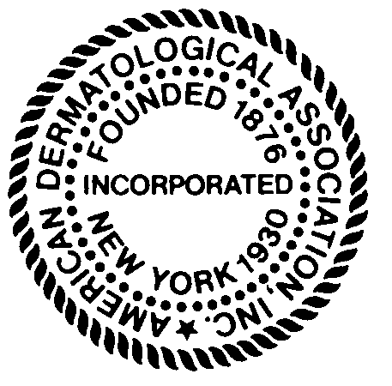
2019 RESIDENT/FELLOW RESEARCH AWARD

CALL FOR PROPOSALS - GENERAL INFORMATION AND REQUIREMENTS

The American Dermatologic Association is pleased to announce its 2019 Dermatology Resident/Fellow research award. Two individuals will be selected for their research specifically related to the following subjects:

- The integral nature of Dermatology in Medicine.
- Issues and matters leading to the marginalization of Dermatology.

- Awardee(s) are required to present their research findings to the general membership of the American Dermatological Association (ADA) at the Annual meeting being held in Sarasota, Florida from August 14th – August 18th, 2019
- The awardees will receive a monetary grant of $500.
- The cost of meeting attendance, along with room and meals will be paid for by the ADA.

Applicants must be an active Dermatology resident in good standing in an ACGME accredited Dermatology program or a Dermatology fellow having completed an ACGME accredited Dermatology residency within the past 5 years. Applicants must have the approval of their chairperson and capacity to present at the 2019 ADA annual meeting. A mentor who is a faculty member of an ACGME accredited Dermatology program must be identified and agree to to provide support for the applicant’s project. (Mentors need not be ADA members.) Applications must be submitted electronically with an attestation from the applicant’s mentor and department chairperson unless they are one and the same.

2018 Resident Research Awardees


Betty Kong, MD, Northwestern University, for her research “The Effect of Market Competition on the Cost of Topical Medications”.


Oluwatobi Ogbechie-Godec, MD, MPH, New York University, for her research “The Diminishing Presence of Dermatologists in the Care of Hospitalized Medicare Patients”.
Application Deadline is June1, 2019
Applications are available online on the ADA website under ADA 2019 Resident Research Award
http://www.ada1.org

Email: ameriderm1930@gmail.com Phone:305-804-1150
The American Dermatological Association is proud to announce the first recipient of the ADA’s President’s Medal
Lifetime Achievement Award

Douglas Lowy, MD
In honor of his basic discoveries and their translation to cancer prevention

Special thanks to the other distinguished speakers at the 138th annual meeting of the American Dermatological Association.
 Angela Christiano, PhD  Lloyd Minor, MD MD

The American Dermatological Association Co-Sponsors American Cancer Society’s HPV Vaccine Policy

Dermatologists routinely engage in the care of patients with mucocutaneous manifestations of Human Papillomavirus infections [HPV]. HPV is associated with protean medical illnesses including cervical, vaginal, vulvar, penile, anal, and oropharyngeal cancers, as well as warts, condylomata, and oropharyngeal papillomas. While there are numerous serotypes of HPV, type 16 and 18 are responsible for the majority of malignancies.
PV infects 79 million people in the United States and is associated with 32,500 cases of cancer in men and women. [https://www.cdc.gov/hpv/hcp/need-to-know.pdf] Worldwide, over a quarter of a million women die of HPV induced cervical cancer yearly. [https://www.who.int/immunization/topics/hpv/en/]
Vaccines are available to protect young women and men against the most pathogenic serotypes and are recommended as part of a routine vaccination schedule for children and young adults. These vaccines markedly reduce the mortality associated with HPV infections.
The American Dermatological Association is pleased to announce its support of the American Cancer Society in its public policy campaign for vaccination against HPV beginning at age 11 or 12 for girls and boys.
The American Dermatological Association also recognizes the expanded age range, between 27 and 45, recently approved by the FDA for male and female HPV vaccination with human papillomavirus 9-valent vaccine.
The American Dermatological Association emphasizes the importance of HPV vaccination at all appropriate ages as a means to reduce HPV-related diseases and recommends that patients consult their health care providers regarding HPV-related diseases.
About the ADA
Mission Statement:
The American Dermatological Association recognizes, discusses and develops solutions for problems in the area of dermatologic health care, research and education.

About the ADA
Founded in 1876, the American Dermatological Association (ADA) was the first national dermatological society in the United States. Its members are recognized leaders in Dermatology research, education, organizational medicine, and patient care. It is charged with advancing scientific endeavor in Dermatology. In the execution of its enduring mission, the ADA spawned the American Board of Dermatology in 1932, the Society for Investigative Dermatology in 1937, and the American Academy of Dermatology in 1938. Membership in the ADA is achieved through nomination and election based on meritorious contributions to the field of Dermatology.

Ethos Statement:
The American Dermatological Association maintains a leadership role in the contemplation and implementation of initiatives that advance the field of Dermatology through research, education, and advocacy. This, in turn, advances the care and treatment of patients with skin disease. As an independent, non-profit, self-funded organization, the American Dermatological Association provides objective analyses and recommendations regarding the complex challenges faced by Dermatology. This is accomplished through stewardship and collaboration with other organizations committed to the ongoing process of advancing the field of Dermatology in the house of medicine.

The American Dermatological Association is funded entirely from membership dues. There are no external or commercial sources of support.

